Library Request

MA in Transformational Urban Leadership
The slums now make up 1 billion people in the world. All future global population increase will be to the slums, so they will increase to 2 billion by 2025. They are the critical target for evangelism. If we reach the slums, we reach the cities. Reach the cities and we reach the nations.

Over the last 8 years the Lord has graciously allowed six schools globally to initiate the MA in Transformational Urban Leadership to train movement leaders in the slums. This is an action-reflection based degree. Go to www.matul.org to see the partnerships. The directors of these schools meet together each year as the MATUL Training Commission to keep developing the program and courses. This year we met in Nagpur and helped this school launch.

Library resources are critical in such reflection and in the launch of any masters program. These schools are not wealthy and lack significant library resources. Those they have are usually from older Christian works and deal with doctrine but little about the realities of slum ministry, pioneering churches, working with street children , getting land rights for the poor, setting up slums schools… The school budgets in reality have nothing in them for getting library resources. The funding of an initial core of books is needed - a simple, clean project, not easily corrupted, that can be funded from outside resources as a capital investment.

We have developed a core list of 150 books for the program (see attached appendix 6). Schools need to obtain local books as well for each course. Because of the difficulties with immigration and customs in these countries, having students or faculty hand carry extra bags on international flights is the preferred way of getting them in.

This would bring each library up to the 150 core books plus 30 local books over two years. Ideally, ultimately they would have about 400 books for the program (i.e. 25 per course) enabling students a range of materials to research and learn from. Urban Books are not big sellers so new ones are expensive. For older books we will seek them from Amazon second hand very good condition. For newer ones we will often ask for free educational copies first (though they don’t like this for overseas universities as much, as it may not add to their market).

This is a request for a funding partner to contribute US$11,550 (NZ$15,400) over two years.

In US$  School | City | Library Size | Current  Urban Books | 30 Local books needed  (@$10 ea) | Needed #Core Books | Core Books Cost est, incl shipp’g to LA | Shipping Costs (est) hand carry fr LA
Asian Theological Seminary, | Manila, Philippines | 34081 titles in 44399 volumes | 1000 | 10 | 33 | $600 | $100
Hindustan Bible Institute | Chennai, India | 40,000 | 150 | 30 | 110 | $1600 | $200
Mission India Theological School | Nagpur, India | 20,000 | 20 | 30 | 150 | $2400 | $300
Carlile College | Nairobi, Kenya | 21,000 | 500 | 10 | 60 | $1200 | $200
Universite Episcopal d’Haiti | Port au Prince, Haiti | 500 | 2 | 30 | 150 in French | $2700 | $300
Totals |  |  |  | $1100 |  | $8500 | $1100
Overheads 5% (money transfers, staff to track down books, bookkeeping, correspondence) |  |  |  |  |  | 1,700 | $850
Total Cost |  |  |  |  |  |  | US$11,550  NZ$15,400
Library shelving costs can be covered by schools.

Contact Information
Funding can be channeled through Urban Leadership Foundation as an NZ registered charity and we will disburse to the schools for local book, and purchase through Amazon or direct from the publishers for the newer ones in the US, and arrange transport (generally hand carried as a second bag by students and faculty to avoid the costly shipping and customs processes) from LA, for the international books.

Urban Leadership Foundation
Correspondence to Viv Grigg viv@urbanleaders.org

Appendix 1: Carlile College Library, Nairobi
Carlisle College is a Church Army (like Salvation Army but within Anglican church) School, with 230 students. For 6 years its Centre for Urban Ministry (based in the slum of Kibera) has graduated 50 slum pastors per year with a Diploma in Urban Ministry. In January 2012, they launch the MATUL to follow on from that.

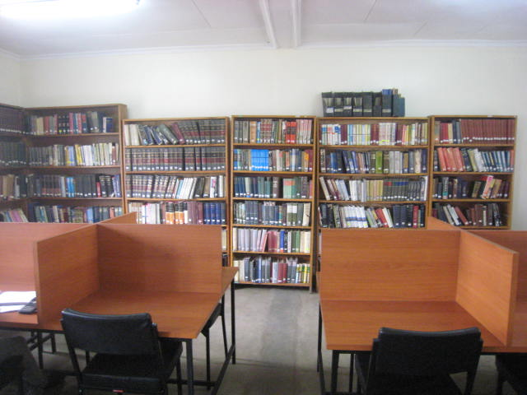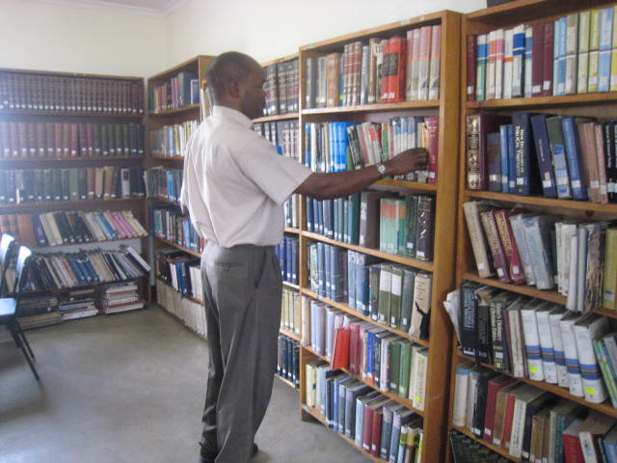

Appendix 2: Universite Episcopal d’Haiti
The University collapsed during the earthquake, killing 200 students and losing its library. Makeshift classrooms have been rebuilt. To launch this program we will need to build a library of 400 urban ministry books.

Pictured below: the Theological Seminary before the quake. Dorms, library, classrooms all fell down. This building was beyond repair. Classes restarted to complete courses in makeshift plywood buildings.

Pere Oge Beuvoir (on right) was instrumental in setting up tent cities and getting immediate temporary classroom built. He will lead the MATUL. Planned start is October 2011. This program that bring s about practical theological responses is desperately needed in Haiti. Books in French will need to be sourced. More expensive.

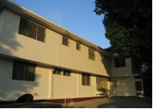 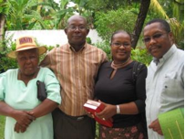 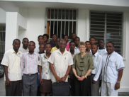 Faculty

Appendix 3: Mission India Theological Seminary, Nagpur, India.
Mission India is launching the program this July, so is the highest priority in this request. It is a school where capital donations from the US have enabled building of massive buildings including an excellent library building developed secluded from the city, a centre of violent Hindu opposition to Christians. It has 800 students, and from here are 24 state training centres, serving 4000 evangelists. Its library is around 20,000 books, but they are old and traditional. No urban ministry books. This is their first venture into urban ministry.

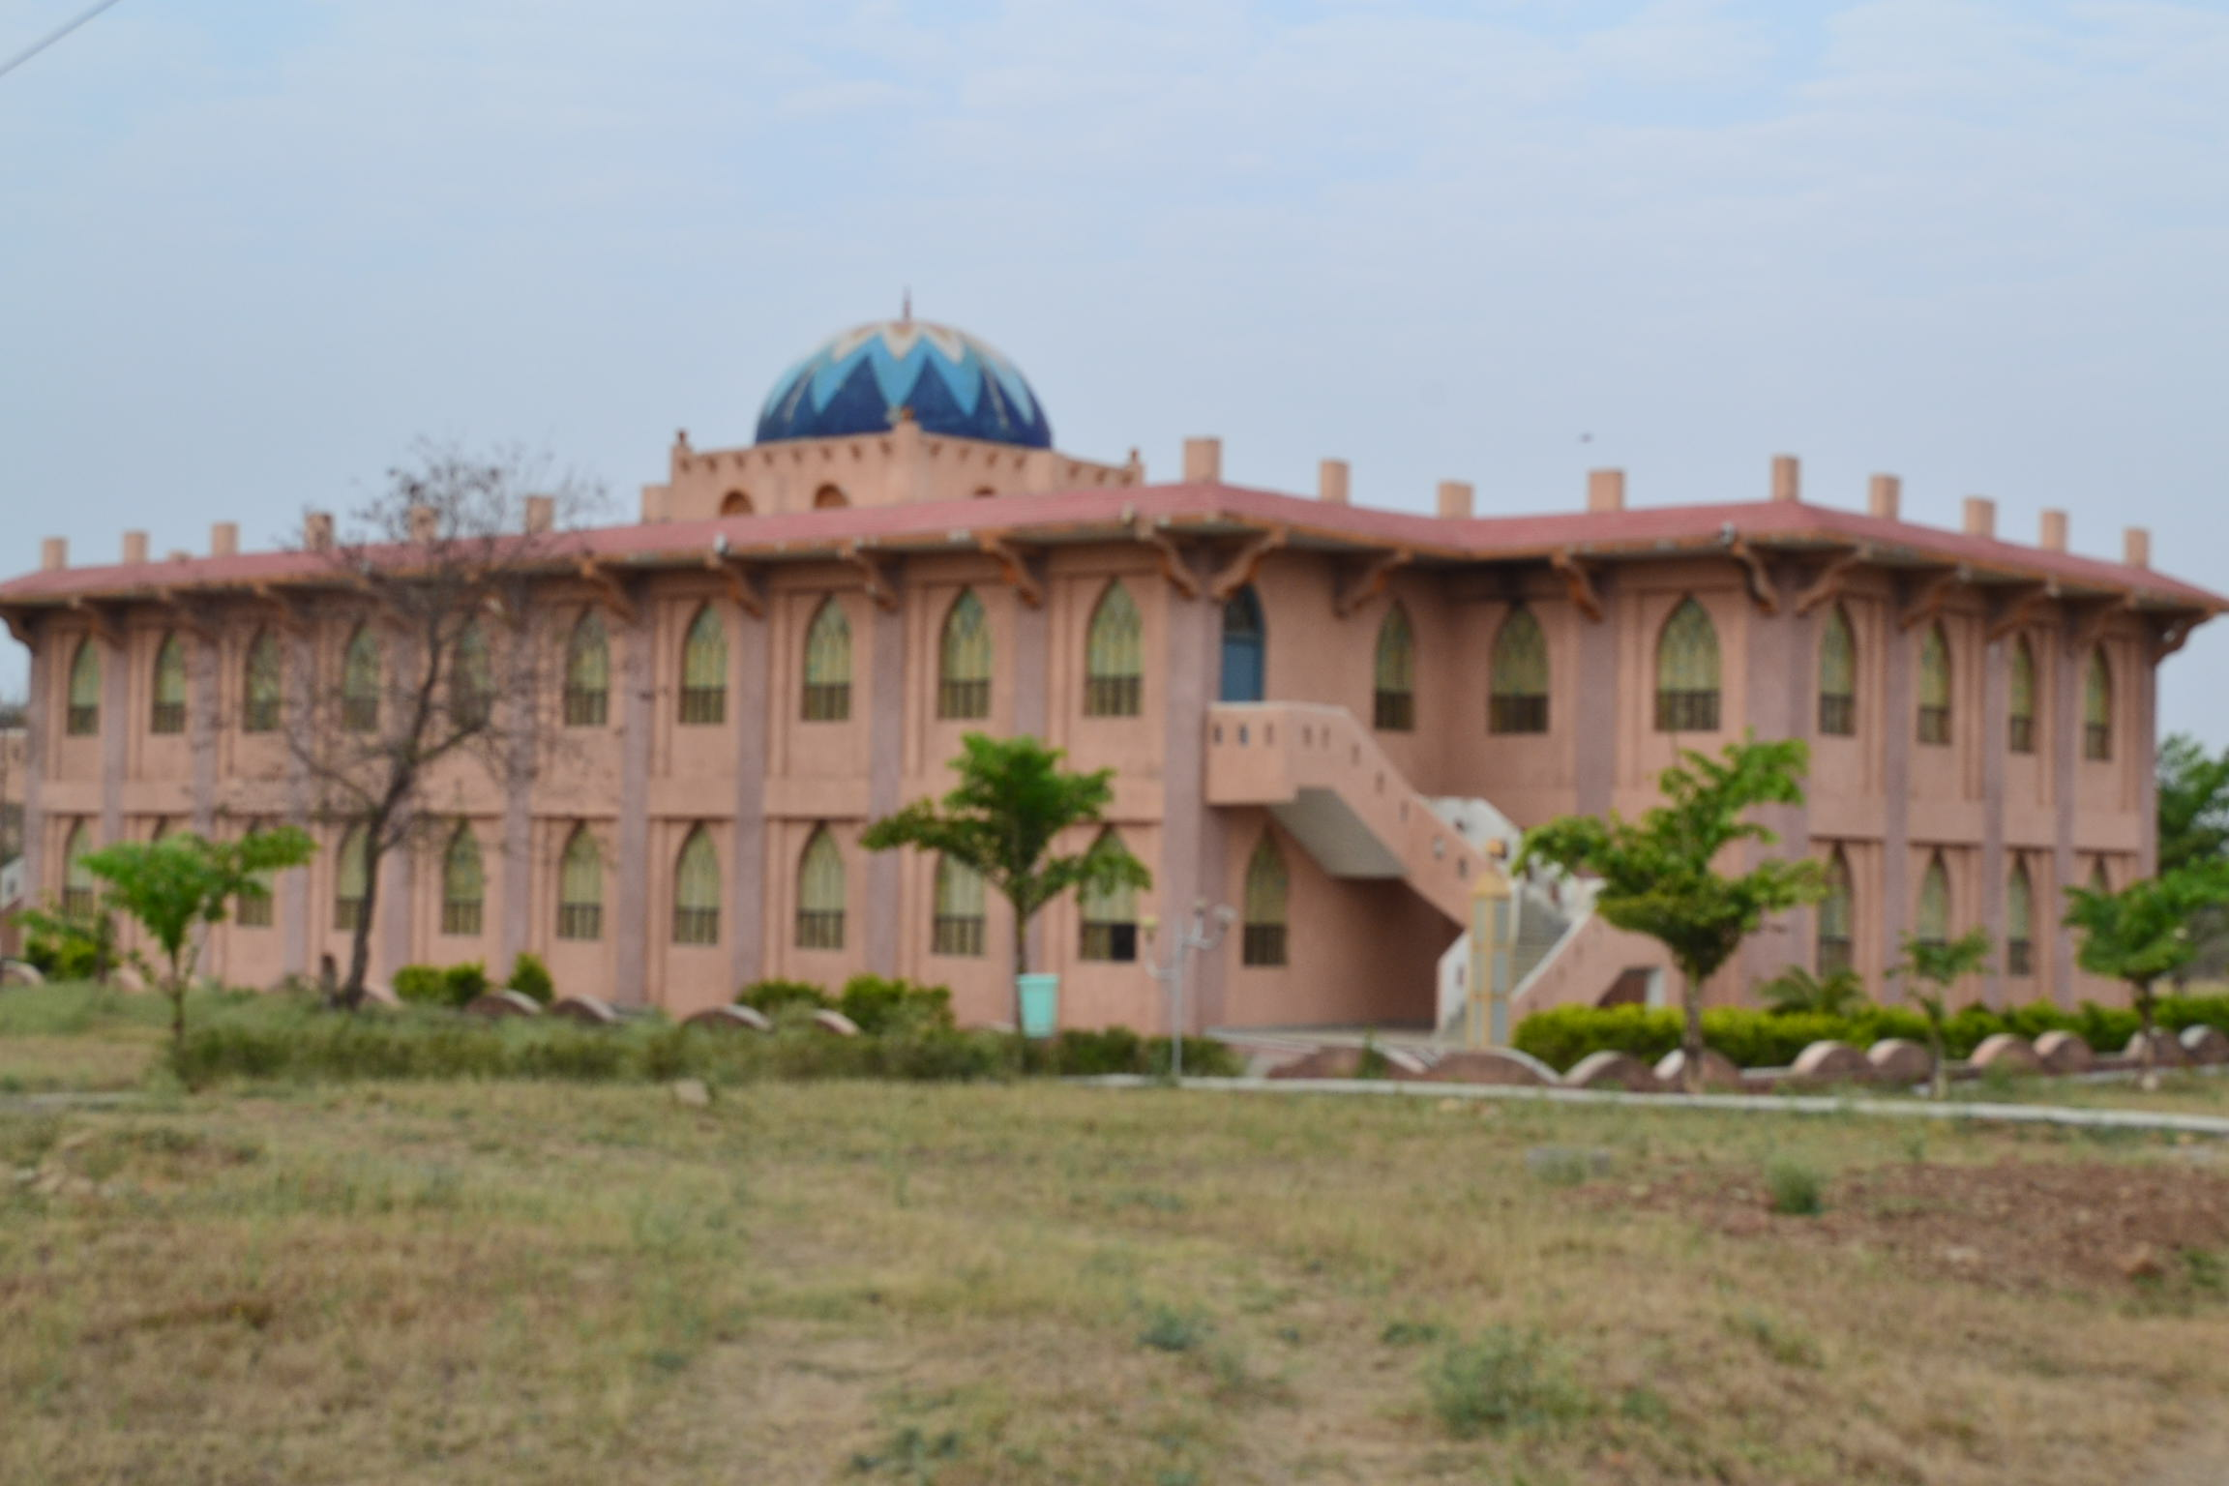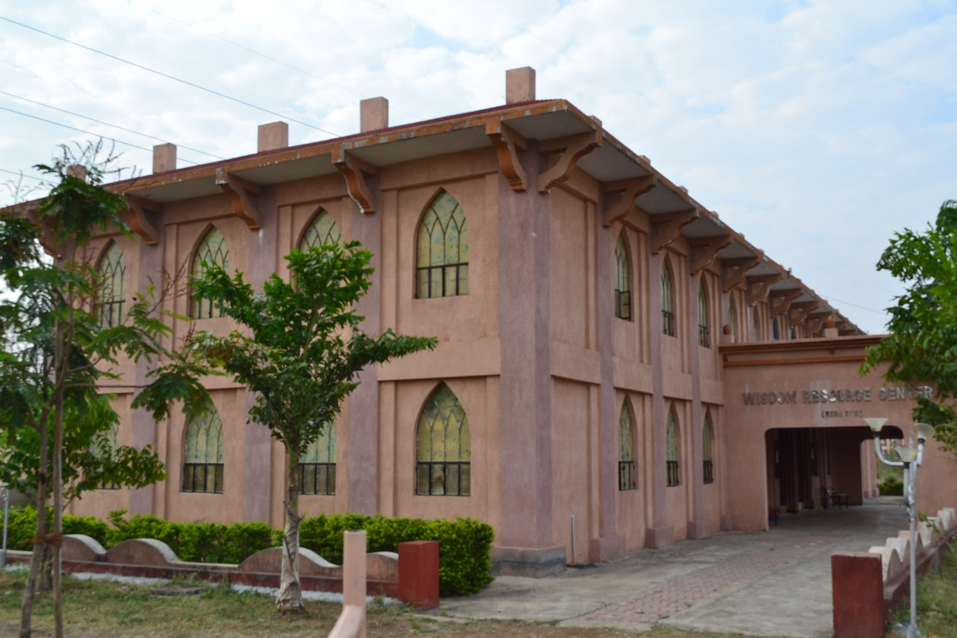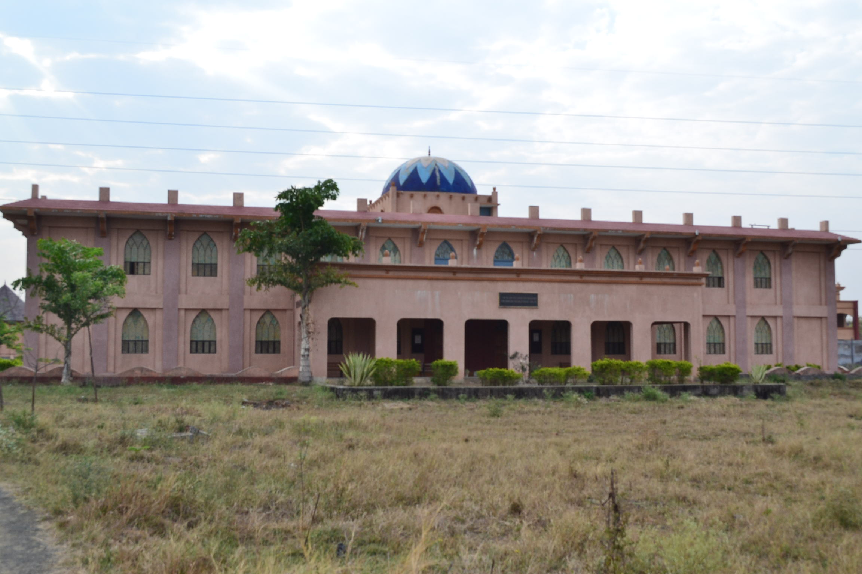

Appendix 4: Hindustan Bible Institute, Chennai, India
Hindustan Bible Institute is a 50 year old Bible School that is the centre for approx. 2000 evangelists. HBI was the first to launch this program 6 years ago. Its graduates are doing amazing work in the slums of Chennai. It has a good library of older theological books and has been slowly building its MATUL section, but is still lacking many of the core books. It has also been quietly buying local Indian books for these subjects.

Appendix 5: ATS Library, Manila, Philippines
Asian Theological Seminary is a non- denominational graduate seminary, which has existed more than 40 years. It offers Diploma, Graduate Diploma, Masters of Arts and Masters of Divinity degrees. It has seven programs, which are: Pastoral Ministry, Biblical Studies, Theology, Christian Education, Counseling, Inter-cultural Studies, Transformational Urban Leadership.

ATS has a student population of almost 250 students. The Center for Transformational Urban Leadership has about 25 students. Most of these students are local urban practitioners, involved in urban ministry. The faculty of the Center are academic practitioners, with academic training, but also with grassroots experience.

The ATS library holds 34081 titles in 44399 volumes. The section for the Center of Transformational Urban Leadership holds almost 1000 titles. ATS launched the MATUL 6 years ago and has graduated a number of students and has a quietly been building its library.

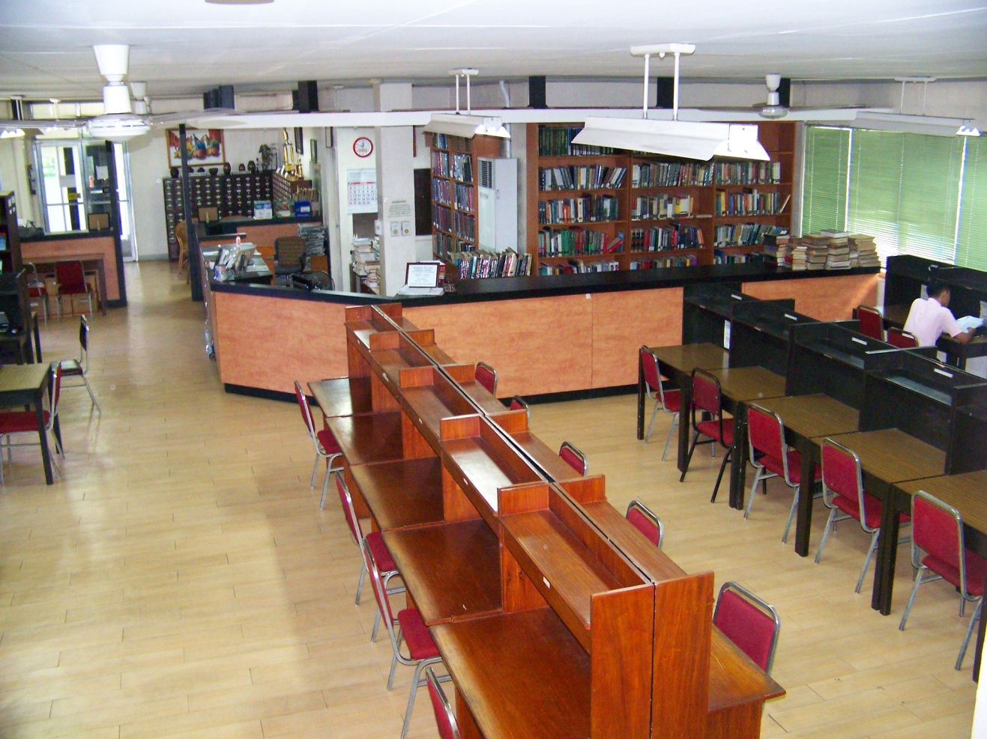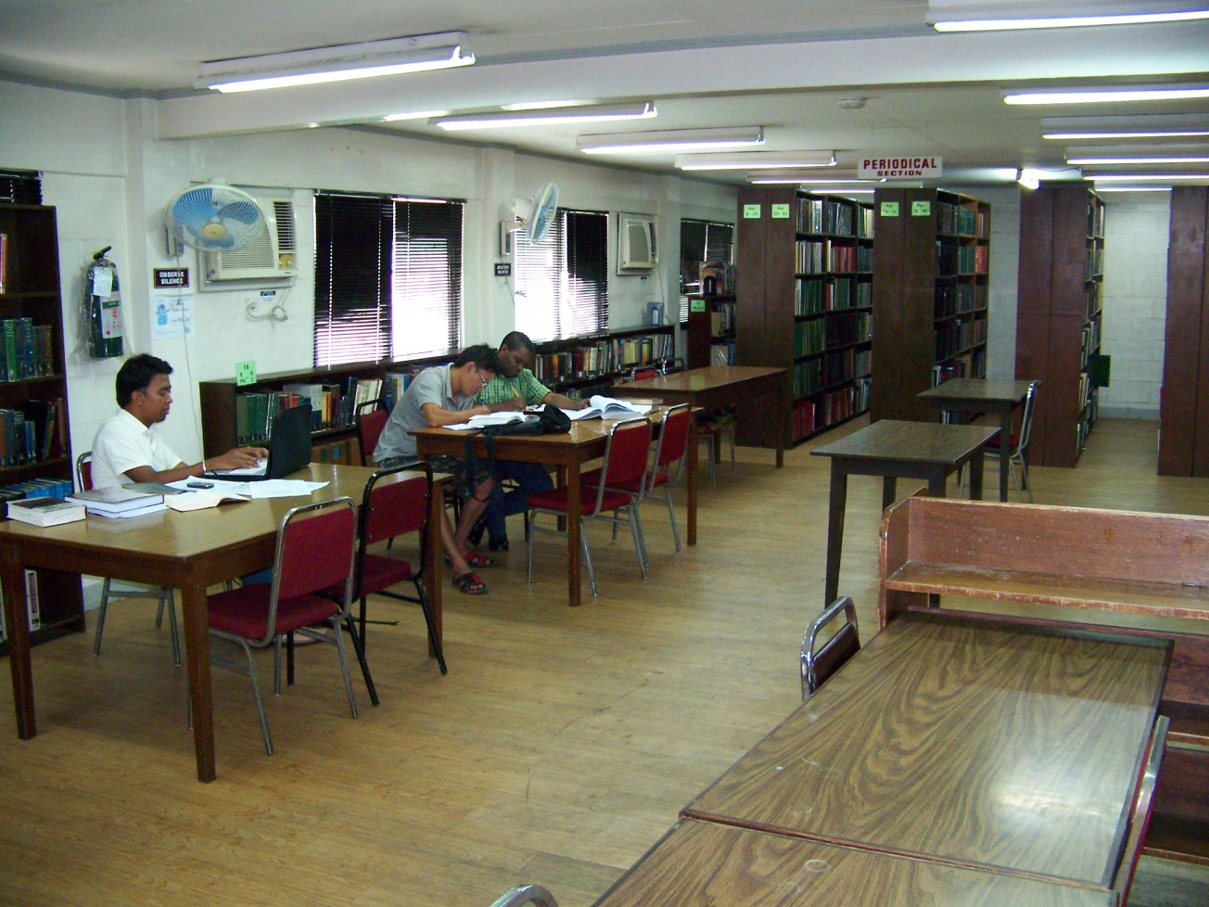
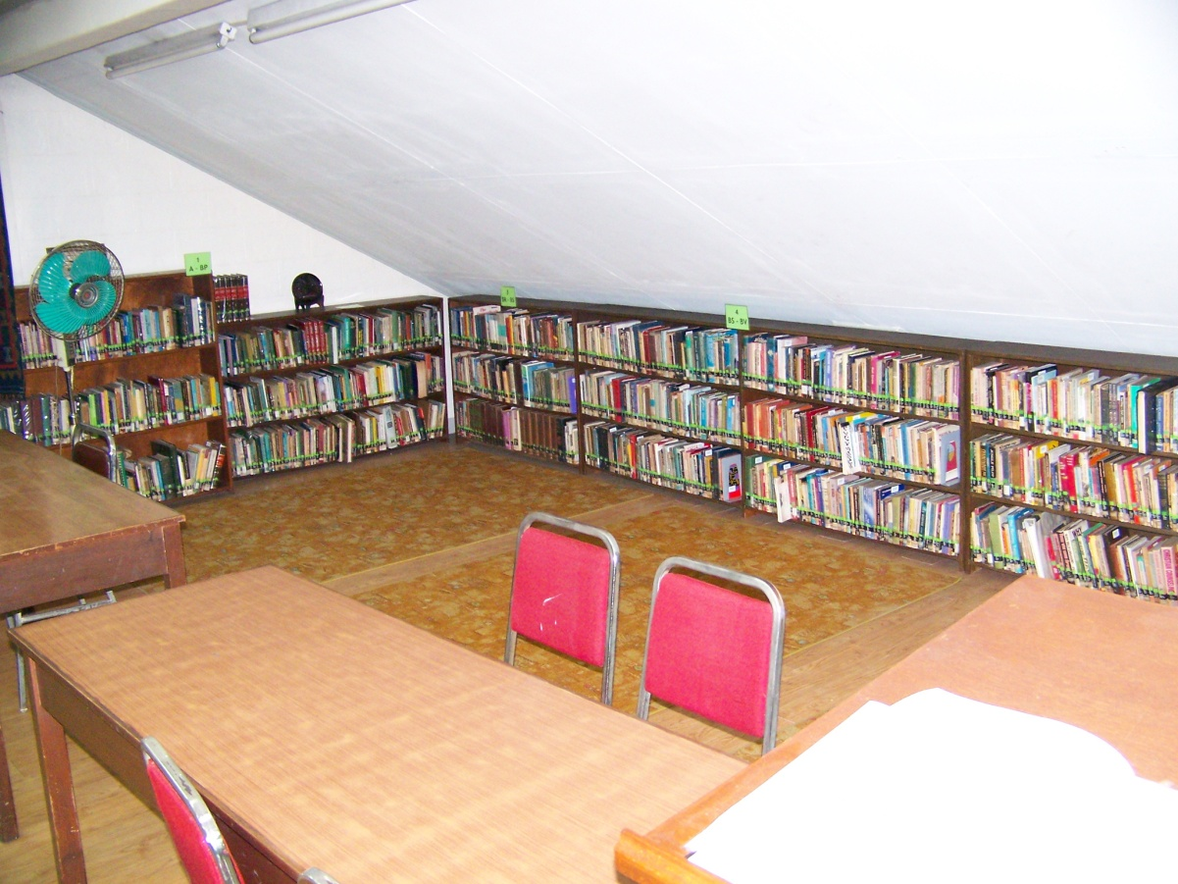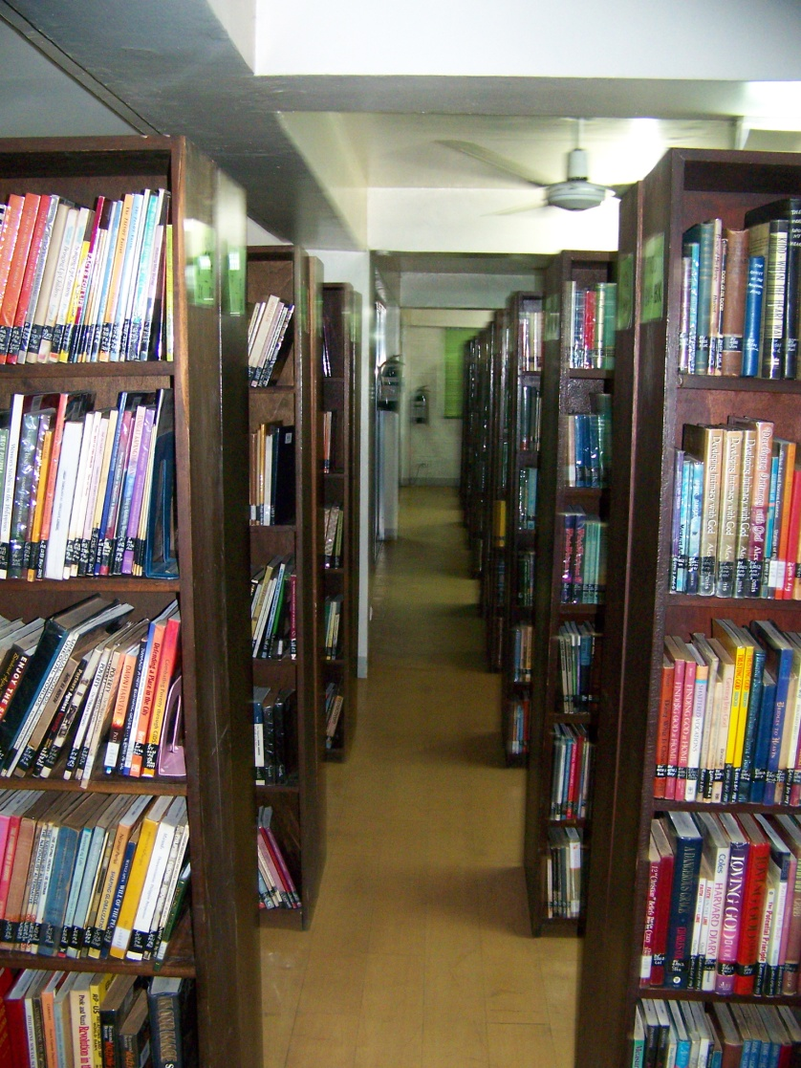

Specific Book titles requested for each library are available if desired.

Appendix 6 is pdf file of 150 core books

